

**Final Report**

<https://github.com/Akshansh3011/Railway-reservation-System>

|  |  |  |
| --- | --- | --- |
| **Sr. No.** | **Registration no.** | **Name** |
| **1.** | **11913642** | **Akshansh Chaudhary** |
| **2.** |  | **Ankit** |
| **3.** |  | **Uma Mahesh** |

**Railway Reservation System**

**Abstract**

The project consists of development of a Railway Reservation System Website for a handy and paperless mode of reserving train tickets.

Website has been design in such a way that a normal person who can use a phone can have access to it a book a train ticket with ease.

Along with reservation website also include other features on railways such as – holiday packages in some world’s best travelling trains with the most luxury and comfort and also other things like PNR enquiry etc.

Railway offers much more than just daily travelling trains.

It has world’s most number of employees.

**Introduction**

**WEBSITE**

A website is a collection of publicly accessible, interlinked Web pages that share a single domain name. Websites can be created and maintained by an individual, group, business or organization to serve a variety of purposes. Together, all publicly accessible websites constitute the World Wide Web.

Websites come in a nearly endless variety, including educational sites, news sites, porn sites, forums, social media sites, e-commerce sites, and so on. The pages within a website are usually a mix of text and other media. That said, there are no rules dictating the form of a website. A person could create a website of nothing but black and white photos of roses, or the word "cat" linked to another Web page with the word "mouse." However, many sites follow a standard pattern of a homepage that links off to other categories and content within the website. Originally, websites were categorized by their top-level domains. Some examples include: Government agency websites = .gov Educational institutions’ websites = .edu Nonprofit organizations’ websites = .org Commercial websites = .com nformation sites = .info Although these top-level domains extensions still exist, they say little about a website's actual content. In the modern day internet, the ".com" extension is by far the most popular domain, a long with many other country-specific extensions.

**Railway website**

As the largest public sector of India railway connects each and every part of country.

And now when it is time of digitalization it also needs a full fleshed online network to interact to public and allow the to use the services provided by them.

And so it website, which is a mode of interaction between public and railway, must be used with least hustle and most ease.

**Objectives**

1. Make a user friendly and hustle free website.
2. Allow the user to have full access to the services provided by it.
3. Make public aware about new policies and services.

**Literature review**

The first railway proposals for India were made in [Madras](https://en.wikipedia.org/wiki/Madras) in 1832. The country's first train, *Red Hill Railway* (built by [Arthur Cotton](https://en.wikipedia.org/wiki/Arthur_Cotton) to transport granite for road-building), ran from [Red Hills](https://en.wikipedia.org/wiki/Red_Hills,_Chennai) to the [Chintadripet](https://en.wikipedia.org/wiki/Chintadripet) bridge in Madras in 1837.[[9]](https://en.wikipedia.org/wiki/Indian_Railways#cite_note-irfca.org-9) In 1845, the *Godavari Dam Construction Railway* was built by Cotton at [Dowleswaram](https://en.wikipedia.org/wiki/Dowleswaram) in [Rajahmundry](https://en.wikipedia.org/wiki/Rajahmundry), to supply stone for the construction of a dam over the [Godavari River](https://en.wikipedia.org/wiki/Godavari_River). In 1851, the *Solani Aqueduct Railway* was built by [Proby Cautley](https://en.wikipedia.org/wiki/Proby_Cautley) in [Roorkee](https://en.wikipedia.org/wiki/Roorkee) to transport construction materials for an [aqueduct](https://en.wikipedia.org/wiki/Aqueduct_(bridge)) over the Solani River.[[9]](https://en.wikipedia.org/wiki/Indian_Railways#cite_note-irfca.org-9)

India's first passenger train, hauled by three steam locomotives (*Sahib*, *Sindh* and *Sultan*), ran for 34 kilometres (21 mi) with 400 people in 14 carriages on [1,676 mm](https://en.wikipedia.org/wiki/5_ft_6_in_gauge_railway) (5 ft 6 in) [broad gauge](https://en.wikipedia.org/wiki/Broad_gauge) track between [Bori Bunder](https://en.wikipedia.org/wiki/Bori_Bunder_railway_station) ([Mumbai](https://en.wikipedia.org/wiki/Mumbai)) and [Thane](https://en.wikipedia.org/wiki/Thane) on 16 April 1853.[[10]](https://en.wikipedia.org/wiki/Indian_Railways#cite_note-10)[[11]](https://en.wikipedia.org/wiki/Indian_Railways#cite_note-11) The Thane viaducts, India's first [railway bridges](https://en.wikipedia.org/wiki/Railway_bridge), were built over the [Thane creek](https://en.wikipedia.org/wiki/Thane_creek) when the Mumbai-Thane line was extended to [Kalyan](https://en.wikipedia.org/wiki/Kalyan) in May 1854.[[12]](https://en.wikipedia.org/wiki/Indian_Railways#cite_note-12) Eastern India's first passenger train ran 39 km (24 mi) from [Howrah](https://en.wikipedia.org/wiki/Howrah), near [Kolkata](https://en.wikipedia.org/wiki/Kolkata), to [Hoogly](https://en.wikipedia.org/wiki/Hugli-Chinsura) on 15 August 1854.[[1]](https://en.wikipedia.org/wiki/Indian_Railways#cite_note-IRFCA-history-page-1) The first passenger train in [South India](https://en.wikipedia.org/wiki/South_India) ran 97 km (60 mi) from [Royapuram](https://en.wikipedia.org/wiki/Royapuram)- Veyasarapady ([Madras](https://en.wikipedia.org/wiki/Madras)) to Wallajah Road ([Arcot](https://en.wikipedia.org/wiki/Arcot)) on 1 July 1856.[[13]](https://en.wikipedia.org/wiki/Indian_Railways#cite_note-13)

On 24 February 1873, a [horse-drawn](https://en.wikipedia.org/wiki/Horsecar) 3.8 km (2.4 mi) [tram](https://en.wikipedia.org/wiki/Tram) opened in [Calcutta](https://en.wikipedia.org/wiki/Kolkata) between [Sealdah](https://en.wikipedia.org/wiki/Sealdah) and Armenian Ghat Street.[[14]](https://en.wikipedia.org/wiki/Indian_Railways#cite_note-14) On 9 May 1874, a horse-drawn tramway began operation in [Bombay](https://en.wikipedia.org/wiki/Mumbai) between [Colaba](https://en.wikipedia.org/wiki/Colaba) and [Parel](https://en.wikipedia.org/wiki/Parel).[[15]](https://en.wikipedia.org/wiki/Indian_Railways#cite_note-15) In 1897, lighting in passenger coaches was introduced by many railway companies. On 3 February 1925, the first electric passenger train in India ran between [Victoria Terminus](https://en.wikipedia.org/wiki/Chhatrapati_Shivaji_Maharaj_Terminus_railway_station) and [Kurla](https://en.wikipedia.org/wiki/Kurla).[[16]](https://en.wikipedia.org/wiki/Indian_Railways#cite_note-core.indianrailways.gov.in-16)

The organization of Indian railways into regional zones began in 1951,[[17]](https://en.wikipedia.org/wiki/Indian_Railways#cite_note-17) when the [Southern](https://en.wikipedia.org/wiki/Southern_Railway_zone) (14 April 1951), [Central](https://en.wikipedia.org/wiki/Central_Railway_zone) (5 November 1951), and [Western](https://en.wikipedia.org/wiki/Western_Railway_zone) (5 November 1951) zones were created.[[18]](https://en.wikipedia.org/wiki/Indian_Railways#cite_note-indianrail.gov.in-18) Fans and lights were mandated for all compartments in all passenger classes in 1951, and sleeping accommodations were introduced in coaches. In 1956, the first fully air-conditioned train was introduced between [Howrah](https://en.wikipedia.org/wiki/Howrah_Junction_railway_station) and Delhi.[[19]](https://en.wikipedia.org/wiki/Indian_Railways#cite_note-19) Ten years later, the first containerized freight service began between Mumbai and [Ahmedabad](https://en.wikipedia.org/wiki/Ahmedabad).

In 1974, Indian Railways endured a [20 day strike](https://en.wikipedia.org/wiki/1974_railway_strike_in_India), which damaged the nation's economy.[[20]](https://en.wikipedia.org/wiki/Indian_Railways#cite_note-20)[[21]](https://en.wikipedia.org/wiki/Indian_Railways#cite_note-21)

In 1986, computerized ticketing and reservations were introduced in New Delhi.[[22]](https://en.wikipedia.org/wiki/Indian_Railways#cite_note-22) In 1988, the first [Shatabdi Express](https://en.wikipedia.org/wiki/Shatabdi_Express) was introduced between New Delhi and Jhansi; it was later extended to [Bhopal](https://en.wikipedia.org/wiki/Bhopal).[[23]](https://en.wikipedia.org/wiki/Indian_Railways#cite_note-23) Two years later, the first self-printing ticket machine (SPTM) was introduced in New Delhi.[[24]](https://en.wikipedia.org/wiki/Indian_Railways#cite_note-24) In 1993, air-conditioned three-tier coaches and a sleeper class (separate from second class) were introduced on IR. The CONCERT system of computerized reservations was deployed in New Delhi, Mumbai and [Chennai](https://en.wikipedia.org/wiki/Chennai_Central_railway_station) in September 1996. In 1998, coupon validating machines (CVMs) were introduced at [Mumbai Chhatrapati Shivaji Maharaj Terminus](https://en.wikipedia.org/wiki/Chhatrapati_Shivaji_Terminus). The nationwide concierge system began operation on 18 April 1999. In February 2000, the Indian Railways website went online.[[25]](https://en.wikipedia.org/wiki/Indian_Railways#cite_note-25) On 3 August 2002, IR began online train reservations and ticketing.[[26]](https://en.wikipedia.org/wiki/Indian_Railways#cite_note-26)

On 31 March 2017, Indian Railways announced that the country's entire rail network would be electrified by 2022 or 2023, and become a net-zero railway by 2030.[[27]](https://en.wikipedia.org/wiki/Indian_Railways#cite_note-indianexpress.com-27)[[8]](https://en.wikipedia.org/wiki/Indian_Railways#cite_note-:5-8)

-Source: Wikipedia.org

**System description**

**Home page(index.html)**

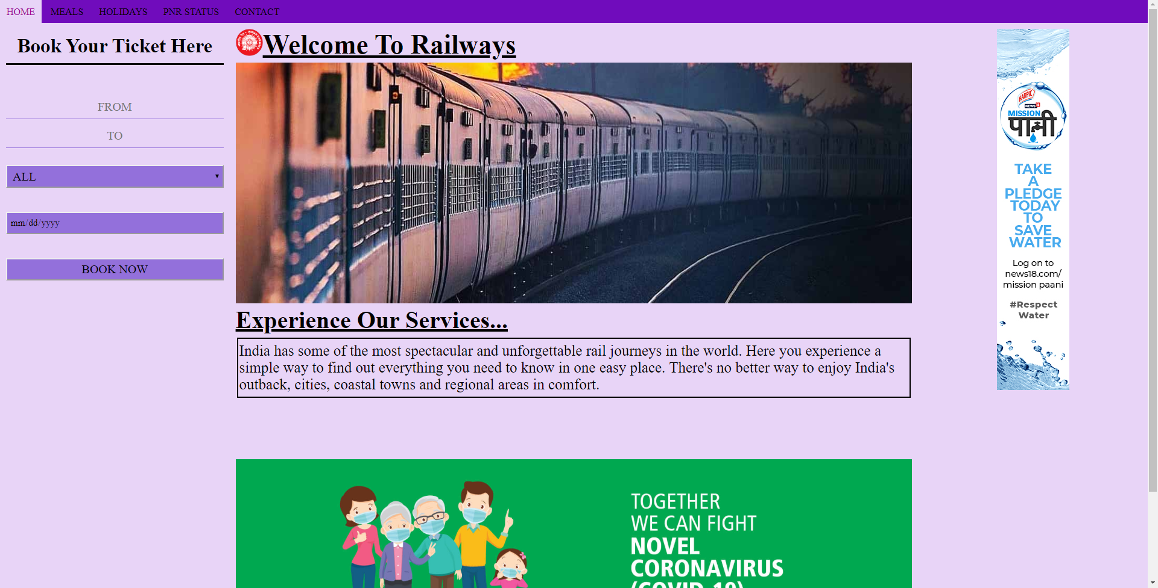

Once the user reaches the home page of website they can have easy access to all things included in the webpage.

Navigation bar has- HOME MEALS HOLIDAYS PNR-STATUS CONTACT options which can be reached directly just by clicking on them

On the left we have our reservation menu. User just has to enter start and end of journey, date and preferred class. The system will then provide him with the available train.

Center we have a visual look for our website telling about the railways along with a banner related to CORONA virus to which user can have access by clicking in case of need of any information regarding the pandemic.

On right there is an ad/awareness column as provided by a standard webpage.

**Methodology**

We have implemented internal css for styling and designing of the webpage.

the styling code is mentioned under the style tag.

We have used normal placement codes of placing text and images at desired location along the resizing commands.

We have included a fixed navigation bar which stays on top of the page while scrolling.

The page has been divided in – Header, left column, middle column, right column and a footer.

The page is responsive and under 600px size its item gets rearranged as to be used on a mobile screen.

The nav bar also changes and items mentioned in it get included in a dropdown menu.

For reservation details input we have used input tags.

Tables have also been used on the page of holidays to describe the fare and other thing related to it.

**Result & Discussion**

I this project we learn so many things which will help in our future life. Like if we are handling a business so we must have a website in which we will publish our work so that our business will grow very quickly. As if we a blogging something we must need a website, for presenting our work .

**Conclusion**

We have tried to make a user friendly website for railway reservation system which has include many functions to let the user have full access to the website and the services provided.

**Reference**

* **https://www.w3schools.com**